DESIGN LOGIC
Design logic refers to the methodology and thought process used to translate the desired behaviour of an electronic circuit into code that can be synthesized into actual physical hardware.

CORE PILLARS OF DESIGN LOGIC OF VERILOG PROGRAM

1. Thinking in Hardware (Concurrency)
The most critical aspect of Verilog design logic is understanding concurrency. In a physical circuit, if you connect power to five different logic gates, they all turn on and process signals simultaneously. Verilog mirrors this. Unless specifically placed inside a sequential block, statements in Verilog execute in parallel. The logic involves designing how these parallel streams of data interact without interfering with each other.
2. Choosing the Level of Abstraction
Verilog allows you to design logic at three different levels of abstraction, depending on how complex your circuit is:
- Gate-Level (Structural) Modeling: This is the lowest level. The design logic involves manually wiring together basic components (like connecting an AND gate's output to an OR gate's input). It is like drawing a schematic using code.
- Dataflow Modeling: As shown in the previous examples, this logic focuses on how data moves through the system using Boolean equations and assign statements. You care about the logical relationship between inputs and outputs, not the specific physical gates.
- Behavioral Modeling: This is the highest level of abstraction. The design logic focuses purely on what the circuit should do, rather than how it is built. You use algorithmic constructs like always blocks, if-else statements, and case statements. The synthesis tool is trusted to figure out the best arrangement of logic gates to achieve that behavior.
3. Modularity and Hierarchy
Good design logic in Verilog relies heavily on modularity. Just like building a house out of bricks, you build complex chips out of simpler blocks.
- You define a self-contained module (like a Half Adder).
- You then instantiate (copy) that module multiple times inside a higher-level module (like a Full Adder). The logic is about establishing clear inputs and outputs (ports) for each block and wiring them together efficiently.
4. Timing and Synchronization
While simple logic gates (combinational logic) react instantly to inputs, complex systems (like memory registers or CPUs) require timing coordination. A massive part of Verilog design logic involves synchronous design—using clock signals to ensure that data moves from one part of the circuit to another in an orderly, predictable, and synchronized manner.

LOGIC GATES
Logic gates are the fundamental building blocks of all digital systems and the foundational elements of any Register Transfer Level (RTL) design. They act as microscopic electronic switches that take one or more binary inputs (0s and 1s, representing low and high voltages) and produce a single binary output based on a specific mathematical rule (Boolean algebra).
Output Of Logic Gates

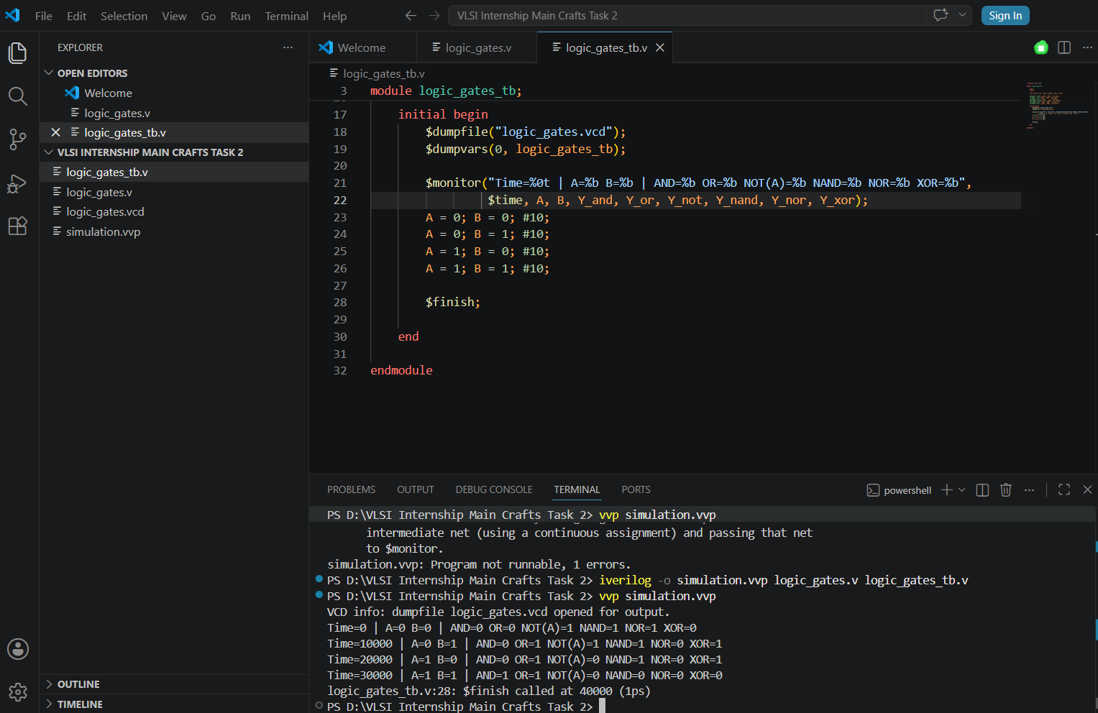

Waveform Of Logic Gates

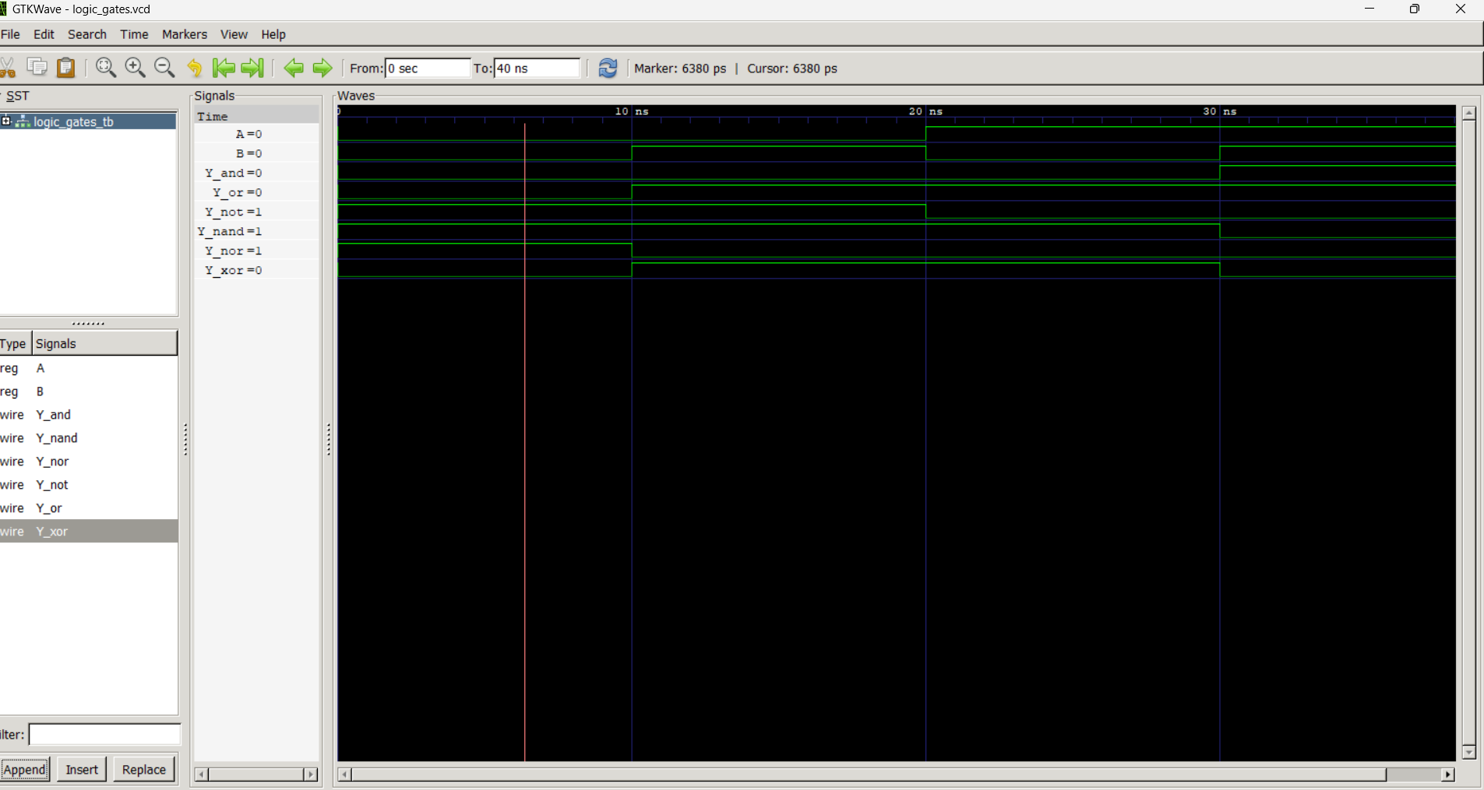

HALF ADDER
A half adder is a fundamental combinational logic circuit in digital electronics designed to add two single-bit binary numbers. It accepts two inputs, typically labeled A and B, and produces two outputs: the Sum (S) and the Carry (C).
Output Of Half Adder

f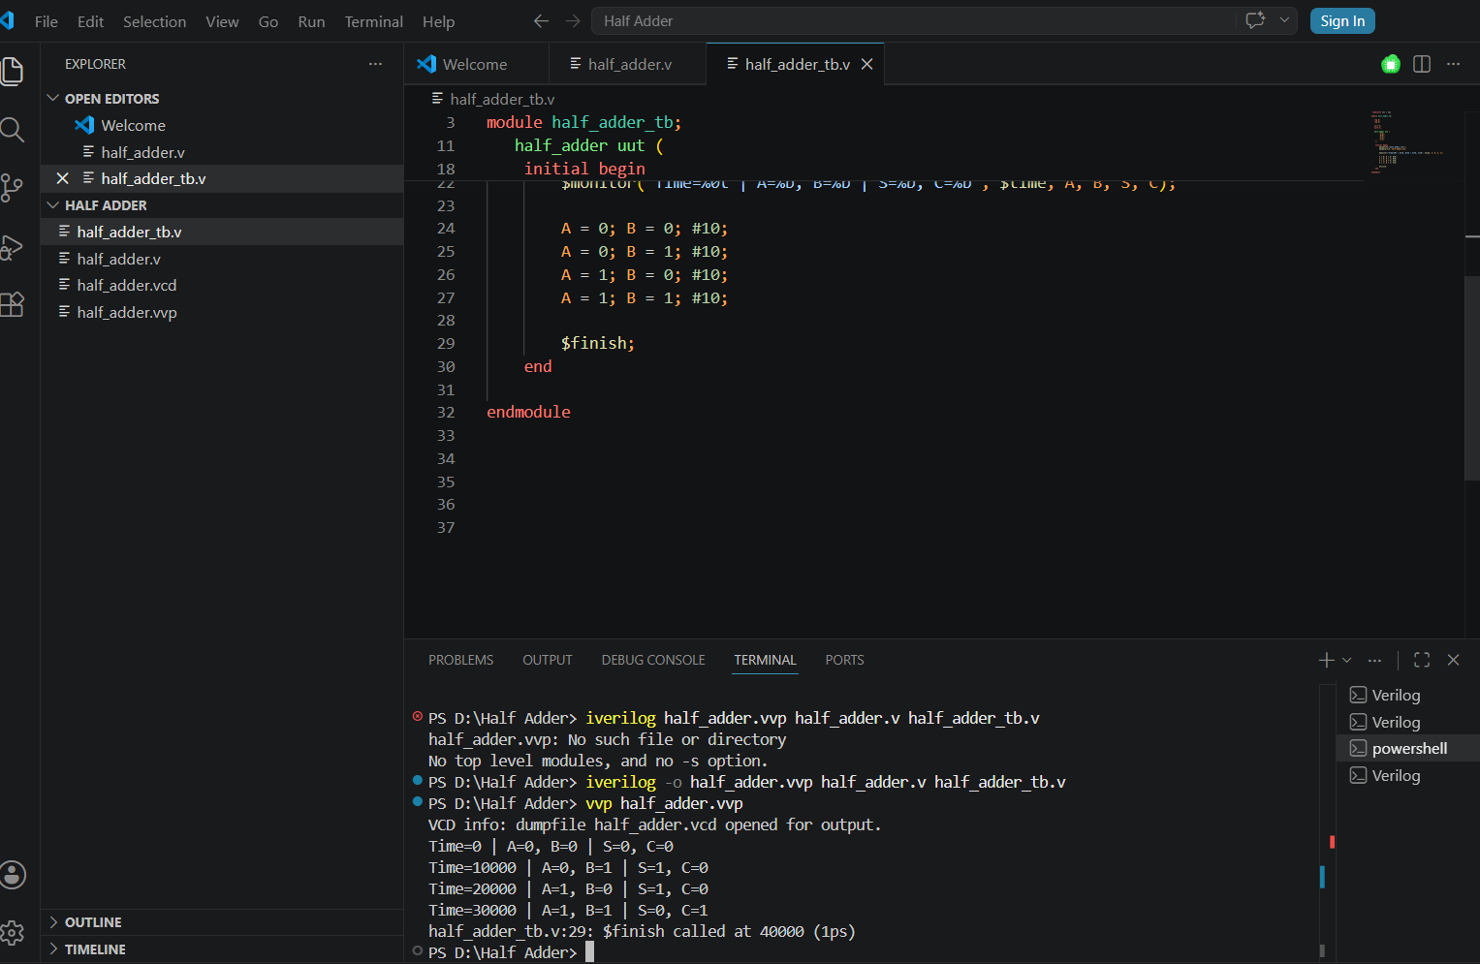

Waveform Of Half Adder

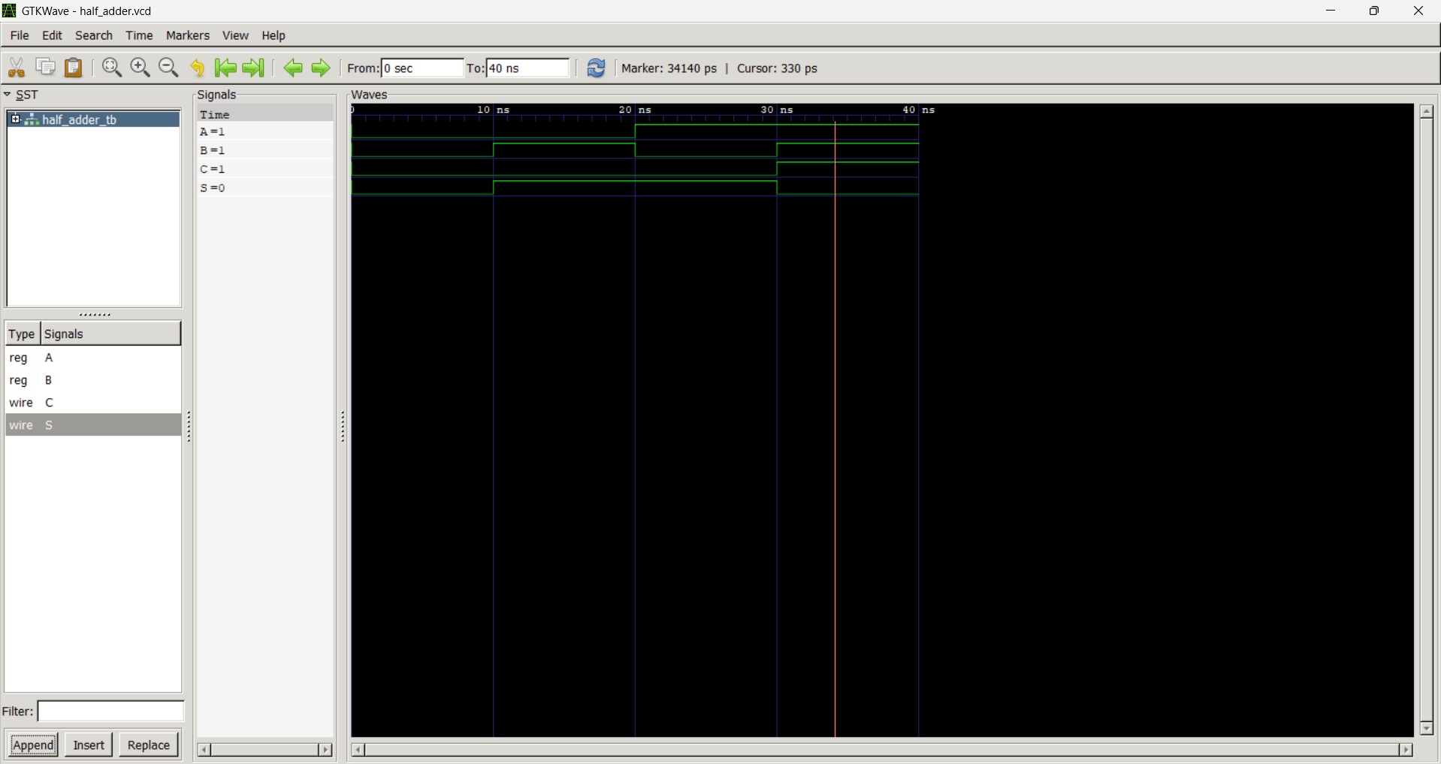

FULL ADDER
A Full Adder is a foundational combination logic circuit used in digital electronics to calculate the sum of three binary bits. It has three inputs A, B, Cin and two outputs Sum(S) and Cout.

Output Of Full Adder

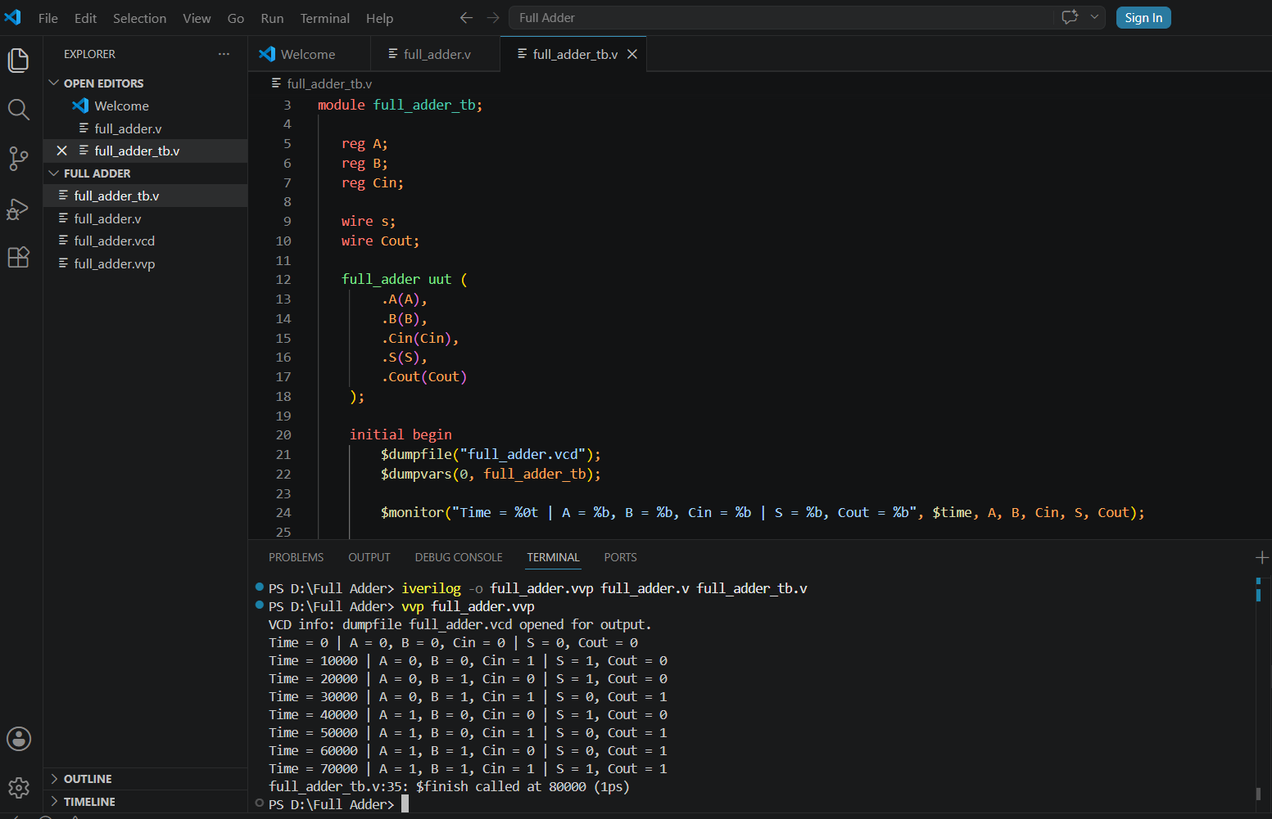

Waveform Of Full Adder

